

A Report on the Course Project of

**Engineering Exploration course (15ECRP101)**

**Titled**

**MECHATRONS**

By

|  |  |
| --- | --- |
| Arjun R | 01FE17BAR007 |
| Amruthraj k | 01FE17BME021 |
| Chaithanya J | 01FE17BME035 |
| Nagaraj | 01FE17BAR030 |
|  |  |

Under the guidance of

**Mr. Adarsh Belavatagi B.E**

**Course instructor, Centre for Engineering Education And Research**

Center for Engineering Education Research

Academic Year 2017-2018, odd Semester



Center for Engineering Education Research

**CERTIFICATE**

This is to certify that the project entitled “MECHATRONS”is carried out by below mentioned students as part of Engineering Exploration Course (15ECRP101), KLE TechnologicalUniversity, Hubballi, during 1stSemester of B.E program for the academic year 2017-18. The project report fulfils the requirements prescribed.

|  |  |  |  |  |  |
| --- | --- | --- | --- | --- | --- |
|  | Arjun R | 01FE17BAR007 |  |  |  |
|  | Amruthraj k | 01FE17BME021 |  |  |  |
|  | Chaithanya J | 01FE17BME035 |  |  |  |
|  | Nagaraj | 01FE17BAR030 |  |  |  |
|  |  |  |  |  |  |
|  |  |  |  |  |  |

|  |  |
| --- | --- |
| Guide  Mr.AdarshBelavatagi  __________________ | Course Instructor  Sanjeev kavle  __________________ |
| Examiner 1:  __________________ | Examiner 2:  __________________ |

**DECLARATION**

We hereby declare that the project work entitled “MECHATRONS” submitted as a part of Engineering Exploration Course during 1st semester of academic year 2017-2018 to KLE Technological University, Hubballi, is a record of an original work done by us under the guidance of Mr. Adarsh Belavatagi. Neither project work nor part of this report is plagiarized to the best of our knowledge.

Date: 22/11/2017

|  |  |  |  |
| --- | --- | --- | --- |
| Your Sign | Your Sign | Your Sign | Your Sign |
| Arjun R | Amruthraj K | Chaithanya J | Nagaraj |
| 143 | 121 | 134 | 165 |  |

**ACKNOWLEDGEMENT**

The success and final outcome of this project required a lot of guidance and assistance from many people and I an extremely privileged to have got this all along the completion of my project. All that I have done is only due to such supervision and assistance and I would not forget to thank them.

I heartily respect and thank our internal project guide Mr.Adarsh Belavatagi who took keen interest and gave his valuable guidance and suggestions during this project work.

I owe my deep gratitude to Mr. Sanjeev K for providing me an opportunity to do the project work and giving us all support and guidance which made complete the project duly. I am extremely thankful to him for providing such nice support and guidance, although he had a busy schedule.

I am thankful and fortunate enough to get constant encouragement, support and guidance from all teaching and no teaching staff of CEER department which helped us in successfully completing our project work. Also, I would like to extend our sincere esteems to all staff in Tinkering lab for their timely support

**Abstract**

**Introduction:** Filling machines were among the first industrial applications

used on large scale. Then later sorting of filled bottles was introduced in later

years based on their size, design, and colour of bottle caps. By the end of

twentieth century, filling and sorting machines had seen more industrial

applications that were never imagined.

**Need Addressed:**A food and beverage company is planning to bring automation in its squash bottleProduction line. It consists of different robots which is responsible for filling up theLiquid (squash) in bottles, sealing, labelling, capping and sorting.

**Procedures:** Gathered answers by questioning relevant questions to the stake holders and by doing some research on the internet.

**Conclusions:** Our project is more efficient cost wise and as well as on the pockets of the stakeholders. Yes we have met all the objectives that we had listed out

An automated optical colour sorting system for sorting plastic bottle containers has been developed as a full-scale prototype and tested at a materials recovery facility. The system employs one vertical chute that sort whole clear containers out of a mixed-colour stream, and is therefore a separation aid for three color sorting. Tests indicate a 70% success rate at 1.25 ton/hr/chute, while the number of chutes used can be matched to pro­ cessing needs. The success rate is 100% after both auto­ mated and manual sorting have been completed. Each chute has a control circuit with three critical variable parameters that can be adjusted to increase the auto­ mated sorter's success rate. A computer simulation and optimization routine have been written to find the opti­mal combination of the three circuit settings. An eco­nomic analysis compares the automated/manual sys­ tem to an all-manual system

**Table of Contents:**

|  |  |
| --- | --- |
| List of Figures | Vii |
| List of Tables | Viii |
| 1. Problem Definition | 1 |
| 1.1. Need Statement | 1 |
| 1.2. Designers | 1 |
| 1.3. Identified Client/Users | 1 |
| 1.4. Literature survey | 2 |
| 1.5. Questions asked to client / users for arriving at Objectives, Functions and Constraints | 9 |
| 1.6. Requirements Analysis | 10 |
| 1.7. List of Objectives | 11 |
| 1.8. Segregated Objectives | 11 |
| 1.9. Objective tree | 12 |
| 1.10. Pair-wise Comparison Chart (PCC) | 12 |
| 1.11. Prioritized Objective List | 12 |
| 1.12. List of constraints | 13 |
| 1.13. List of functions | 13 |
| 1.14. Problem Statement | 13 |
| 2. ProjectSchedule | 14 |
| 3. Conceptual Design | 15 |
| 3.1. Black Box Representation | 15 |
| 3.2. Glass Box Representation | 16 |
| 3.3. Morphological Chart | 17 |
| 3.4. Concept Generations Using Morphological Chart | 18 |
| 3.4.1.Concept 1 | 19 |
| 3.4.2.Concept 2 | 20 |
| 3.4.3.Concept 3 | 21 |
| 3.4.4.Concept 4 | 22 |
| 3.5. Assigning the Weight age to the Objectives | 22 |
| 3.6. PUGH Chart | 23 |
| 4. Detailed design | 24 |
| 4.1. Detailed Drawing | 24 |
| 4.2. Electrical/Electronic Circuit Diagram | 25 |
| 4.3. Bill of materials | 26 |
| 4.4. Flow Chart for the Program | 27 |
| 4.5. Arduino Program | 28 |
| 4.6. Project Backlog Sheet | 31 |
| 4.6.1. Identified Functions | 32 |
| 4.6.2. Sub systems Identified based on the functions | 32 |
| 5. Implementation | 33 |
| 5.1. Photographs | 33 |
| 5.2. Project Implementation Progress | 36 |
| 5.3. Statement of Expenditure | 37 |
| 6. Limitations of Present work and Future Scope | 38 |
| References |  |

**List of Figures**

|  |  |  |
| --- | --- | --- |
| Fig. 1 | Sorting by color | 2 |
| Fig. 2 | Sorting by size | 2 |
| Fig. 3 | Sorting by shape | 3 |
| Fig. 4 | Automatic sorting machine | 3 |
| Fig. 5 | Block diagram of product | 4 |
| Fig. 6  Fig. 7  Fig. 8 | Schematic illustration of automatic sorting system  Sensors used for detecting  Design of detecting system | 5  6  6 |
|  |  |  |
|  |  |  |

**List of Tables**

|  |  |  |
| --- | --- | --- |
| Table. 1 | **Questions asked to client** | 9 |
| Table. 2 | **Requirements Analysis** | 10 |
| Table. 3 | **List of objectives** | 11 |
| Table. 4 | **Segregated objectives** | 11 |
| Table. 5 | **Pair wise comparison chart** | 12 |
| Table. 6 | **Prioritized Objective List** | 12 |
|  |  |  |
|  |  |  |

**1. Problem Definition**

|  |
| --- |
| **A food and beverage company is planning to bring automation in its squash bottleProduction line. It consists of different robots which is responsible for filling up theLiquid(squash) in bottles, sealing, labeling, capping and sorting.** |

**1.1. Need Statement**

**A food and beverage company is planning to bring automation in its squash bottleProduction line. It consists of different robots which is responsible for filling up the Liquid (squash) in bottles, sealing, labeling, capping and sorting.**

**1.2.Designers**

|  |  |  |
| --- | --- | --- |
| Sl.No | Name | USN |
| 1 | **Arjun Rao** | **01FE17BAR007** |
| 2 | **Amruthraj K** | **01FE17BME021** |
| 3 | **Chaitanya J** | **01FE17BME035** |
| 4 | **Nagaraj** | **01FE17BAR030** |

**1.3. IdentifiedClient/Users:**

**FOOD AND BEVERAGE COMPANIES**

**PHARMATEUCAL COMPANIES**

**FERTILISER COMPANIES**

**1.4. Literature survey**

Historical benchmark:-

Since the industrial revolution, filling machines were among the first industrial applications used on large scale. Then later sorting of filled bottles was introduced in later years based on their size, design, and colour of bottle caps. By the end of twentieth century, filling and sorting machines had seen more industrial applications that were never imagined.

1) What are existing solutions to the problem?

Sol:-**Sort by colour-**Bottle caps come in a variety of colors ,especially milk caps, steel caps and so on. We use majorly three colours that are red, green, blue. Sorting bottle caps by colors is an excellent activity for beginning sorters, and students will frequently want to do.

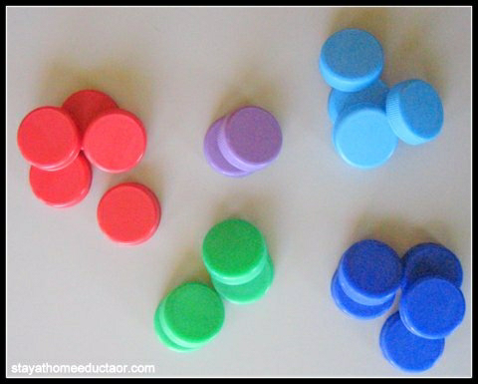

**Sort by size-** Look around your pantry and you will find that bottle caps come in various sizes. Products like peanuts butter are very very large, while the caps to bottled water of vinegar are quite small. Sorting by size is an easy way to support early measurements skills.

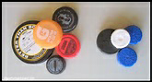

**Sort by design-**Some bottle caps have writing on the top, some do not. Some bottle caps have written logos, some logos are pictures .this really adds to the difficulty of an otherwise basic sorting activity, and many more types of bottle sorting we can see based on the types of cap of bottles.

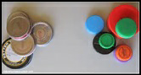

**Sort by shape of bottle**-some bottle can be sorted based on the shape of the bottle. Bottle have many different shapes which is easy to sort.

2) what is working principal behind the existing products?

Sol:-The working principal behind automated bottle sorter based on color is as follows:-

Colour Sorter's **working principle** is according to the difference of the optical properties of the material, use photoelectric detection technology automatic sorting the heterochromatic granule from raw material.

**Colour sorters or color sorters** (sometimes called **optical sorters** or **digital sorters** or **electronic colour sorters**) are machines that are used on the production lines in bulk food processing, automated bottle sorting and other industries . They separate items by their colours, detecting the colours of things that pass before them, and using mechanical or pneumatic ejection devices to divert items whose colours do not fall within the acceptable range.

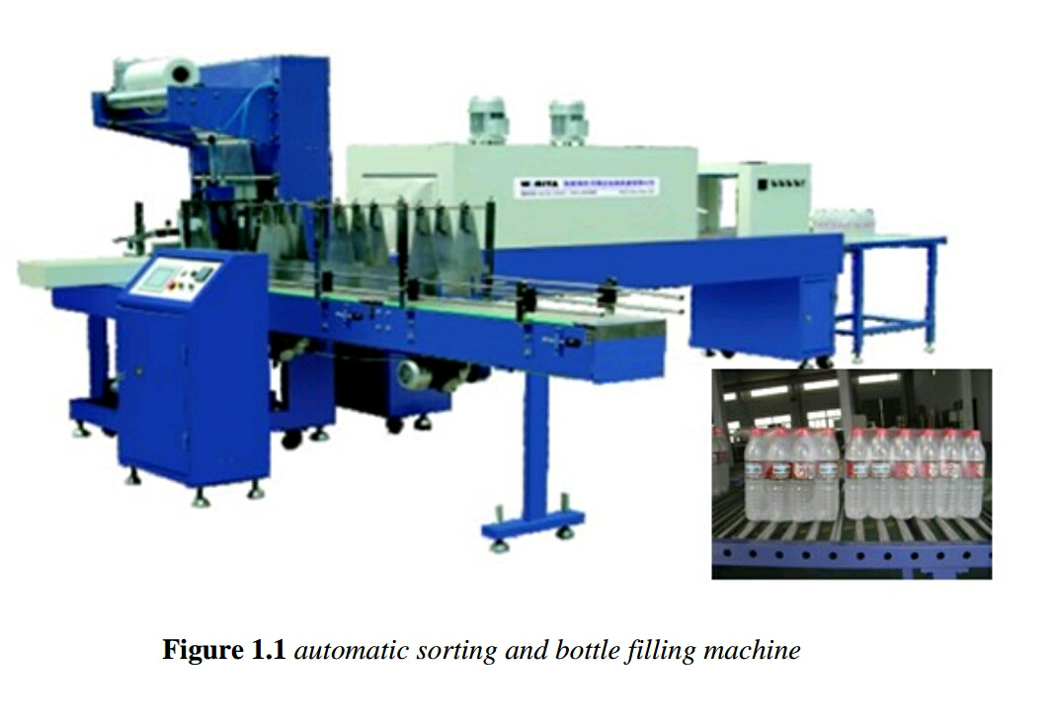

3)what are different components or sub components of existing products?

sol:-1)bottle with color cap

2) Conveyer belt

3) Energy

4) Motors

5) Safety

4)Based on knowledge about existing products, what all technology, components or modules for the design of product?

Sol:-1) Bottle with color cap

2) Feed circuit

3) Position detector

4) Color detector

5) PIC16F877

6) Motor drivers

7) LCD

8) Arduino software

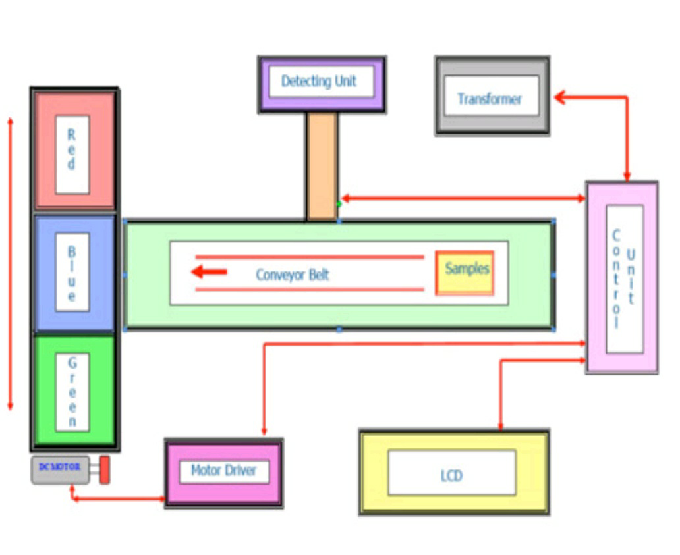

5)do you have expertise about the technology, components or modules needed for your course project?

Sol:-yes, as students of engineering exploration course and mechatronics system study. We are qualified enough to generate a working model for the said problem statement, Having expertise in Audrinowe can programme the system to follow given instructions and generate output.

6) Can you identify the people of different expertise which you need for designing across the institute?

Sol:-yes, since it is a mechatronics system we need different expertise to feed the program and create the feed circuits for automated process, hence we need,

1. Mechanical engineer
2. Electronics engineer
3. Computer engineer
4. Control system

7)working and design process of automated bottle sorting system

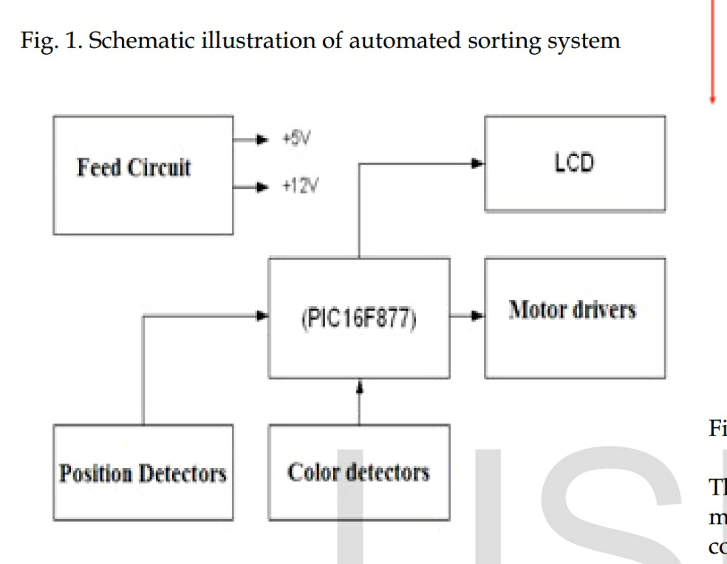

Sensors used for detecting

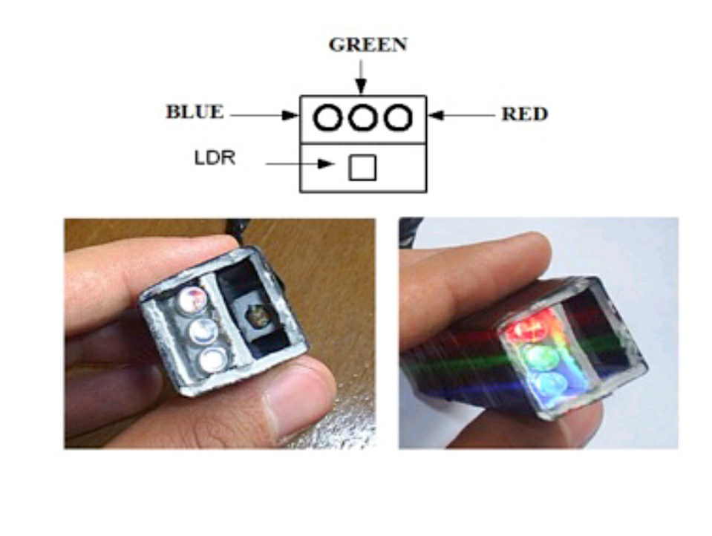

Design of detecting system:-

The detecting system is made by hand. These elements makes the system to run by detecting the color of samples on conveyor belt with the distance 20-40mm where it is used LDR to sense color. It is designed the detecting system as shown in figure below with the usage of LDR. LDR should be insulated from the light through the color sorting system.

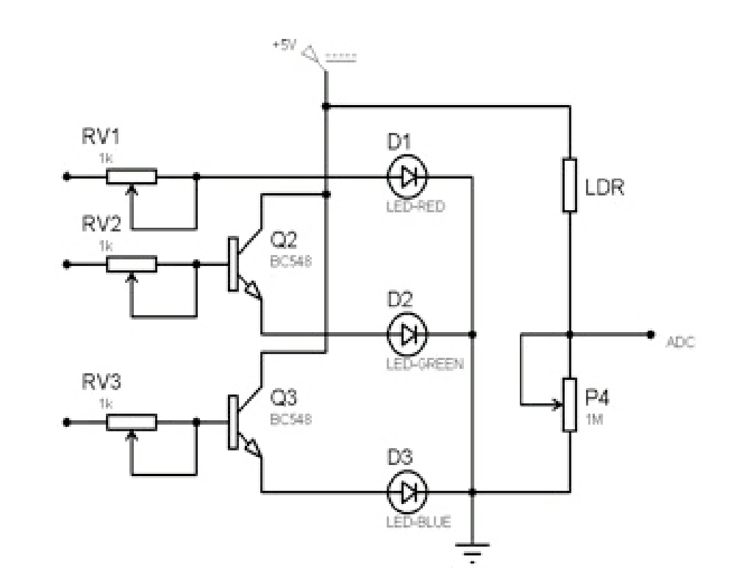

7) What other factors are important to the problem solutions?

Sol:-1) safety is the main precaution to be taken

2) Non poisonous(non toxic)

3) compact in size

4) Non harmful to the human body

5) Light weight

6) Easy to maintain

7) less cost/less maintainence cost

8) Easy to understand and use

8) When compared with your problem statement, what is wrong with the way the problem that will be solved by other teams?

Sol:-A mistake anyone would make is of, Misconfigure the RBG values that would cause a problem because the RBG values change based on lighting of surrounding. To overcome this issue we need to configure the input in such a way that the system accept a particular color if it has 90% of its RBG values.

9) How much people pay for a solution to the problem?

Sol:-1) sorting the plastic bottles-11,500-12,500

2) Intelligent PET bottle sorter-12,500-13,500

3) Plastic PET bottle sorting machine-77,500-83,000

4)stainless steel PET plastic bottle sorting machine-30,000-90,000

10) Have you met and discussed with any other teams who have selected the same need statement?

Sol:-yes, we have met the other team members and discussed about the problem related to need statement.

11) Do they have any solution ideas? What are their ideas to design the product?

Sol:-No, the team members are still not having idea how to design the product.

12) When compared with your problem, what is wrong with the way the problem that will be solved by others teams?

Sol:- when compared to our need statement all the teams should work together to get the desired product, the wrong way is that the problem is not solved all the members of team and they should work in teams to solve problem

13) What is the right way to solve the problem?

Sol:- the problem should be solved by all the members of a team to get our problem solved.

**1.5. Questions asked to client / users for arriving at Objectives, Functions and Constraints.**

|  |  |
| --- | --- |
| **Q. No** | **Questions** |
| 1 | How much can it cost? |
| 2 | What all features are expected? |
| 3 | What can be the size of the product? |
| 4 | what shape and material can the product be made of? |
| 5 | Till what date you you need the product? |
| 6 | What type of power supply you want/to be used? |
| 7 | Where should the product to be installed? |
| 8 | How many bottles to be sorted at once? Or, per minute? |
| 9 | On what basis bottles should be sorted? |
| 10 | Where should the sorted kept? |
| 11 | Which type of product you want like, portable or fixed? |
| 12 | The product should easy to use? |
| 13 | At what range of weight to be expected? |
| 14 | What other features to be expected? |
| 15 | How should the product operates? |
| 16 | How sorting is obtained from the product? |
| 17 | What is the maintanence charge of the produt? |
| 18 | What sensor to be used for sorting? |
| 19 | Should the machine work on AC or DC circuit? |
| 20 | Should be fully automated or semi automated system? |

**1.6. Requirements Analysis.**

|  |  |  |  |  |
| --- | --- | --- | --- | --- |
| **A. no** | **Answer** | **O** | **C** | **F** |

|  |  |  |  |  |
| --- | --- | --- | --- | --- |
| 1 | It would cost around Rs 3000 to 4000 |  |  |  |
| 2 | Sorting based on colour of cap and bottles should be moved to their respective places. |  |  |  |
| 3 | The size of product should be small as possible required for the sorting |  |  |  |
| 4 | The shape should be well designed with no sharp edges and it should be made from suitable material needed for the product |  |  |  |
| 5 | Within three to four weeks |  |  |  |
| 6 | It should work on electricity |  |  |  |
| 7 | The product should be installed along with the squash filling,  Capping machine |  |  |  |
| 8 | Nearly 2 bottles should be sorted per minute |  |  |  |
| 9 | The bottle sorting should be based on colour of the cap. |  |  |  |
| 10 | The sorted bottles should move differently(based on colour of  Cap) and should arranged in groups for packaging. |  |  |  |
| 11 | The product beportable |  |  |  |
| 12 | The product is easy to use and simple in operation |  |  |  |
| 13 | The product should be light weight so that it is portable. |  |  |  |
| 14 | The process should be fast so that the bottles are sorted soon |  |  |  |
| 15 | The product will works on sensors needed for product |  |  |  |
| 16 | The sorting is expected based on colour of cap |  |  |  |
| 17 | The maintenance charge depends on usage of the product |  |  |  |
| 18 | Colour sensor |  |  |  |
| 19 | It works on ac supply converted to dc current |  |  |  |
| 20 | It should be fully automated system |  |  |  |

**1.7.List of Objectives**

|  |  |
| --- | --- |
| **Sl. No** | **Objectives** |
| **1)** | **It should be made from material suitable for the product** |
| **2)** | **It must be inexpensive** |
| **3)** | **It must have less maintenance charge** |
| **4)** | **The product must be simple and should be simple in operation** |
| **5)** | **It should be light in weight** |
| **6)** | **It should not have sharp edges and easy to use** |

**1.8.Segregated Objectives**

|  |  |  |
| --- | --- | --- |
| **Category1: Safety** | **Category2: Cost** | **Category3: User friendly** |
| **No sharp edges** | Inexpensive | Simple in operation |
| **material suitable for product** | Less maintenance | Portable |

**1.9. Objective tree**

Bottle sorting system

safety

cost

User friendly

No sharp edge

Material suitable for product

inexpensive

Less

maintenance

Simple

operation

portable

**1.10.Pair-wise Comparison Chart (PCC)**

|  |  |  |  |  |
| --- | --- | --- | --- | --- |
| **Goals** | **cost** | **safety** | **User friendly** | **Score** |
| **Cost** | **** | 0 | 2 | 2 |
| **Safety** | 2 | **** | 2 | 4 |
| **User friendly** | 1 | 0 | **** | 1 |

**1.11. Prioritized Objective List**

|  |  |
| --- | --- |
| **Sl. No** | **Objective** |
| 1 | CONVENIENCE |
| 2 | COST |
| 3 | ACCURACY |
| 4 | STANDARD PARTS (More the maintenance less the priority) |

**1.12.Listof constraints**

|  |  |
| --- | --- |
| **Sl.No** | **Constraints** |
| 1) | The size of product should be small as possible required for the sorting |
| 2) | The size of the bottle is 8 inches |
| 3) | The product be portable |
| 4)  5) | The product should be light weight so that it is portable and should not have edges  The robotic arm must be capable of picking and placing or slide the object around 600grams |

**1.13.List of functions**

|  |  |
| --- | --- |
| **Sl. No** | **Functions** |
| 1) | Sense the presence of bottle. |
| 2) | Locate the bottle |
| 3) | Approach the bottle |
| 4) | Placing the sensor on top of the bottle. |
| 5) | Sensing the colour of the cap/shape/size of the bottle |
| 6) | Placing the bottle in assigned zones. |

**1.14.Problem Statement**

|  |
| --- |
| “Design a bottle sorting machine for food and beverage company which is simple to operate and made up of any material suitable for the product. The sorting is to be made based on colour of the cap/shape/size which works on sensors which is fully automated. Cost of the machine should range from Rs.3000/- to Rs.4000/- .the product must be light in weight so that it is portable and should not have sharp edges .The size of the bottle is around 8 feet and should be capable of picking and placing or slide the object which is around 600grams and sorting is done following the functions”. |

**2. Project Schedule**

Create the Gantt chart of your entire project work using Gantt Project software. Export the Gantt chart as a report with proper details into a PDF file. Take the snapshot of all pages of the PDF report and paste them here. Paste one snapshot per page

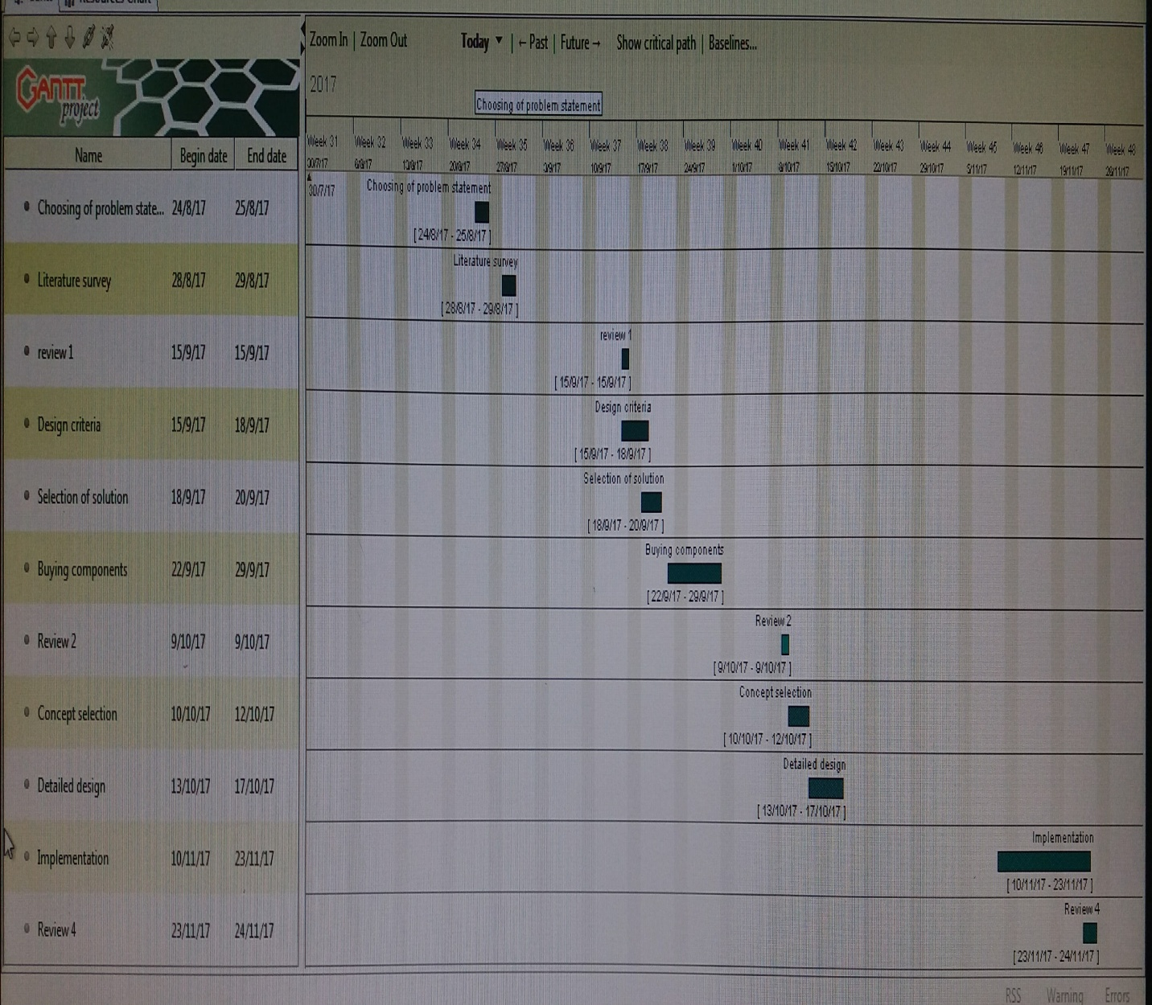

**3. Conceptual Design**

**3.1.Black Box Representation:**

BLACK BOX

**Power**

**(smps)**

**Bottle Sorted bottle**

**With color cap**

**User defined**

**functions**

**3.2. Glass Box Representation**

Sensors

ICU

Identify colour/shape

Motors

Robotic arm/machine Sorting

**Power**

**Sorted bottle**

**bottle**

**input**

**3.3. Morphological Chart:**

|  |  |  |  |  |
| --- | --- | --- | --- | --- |
|  | Means 1 | Means 2 | Means 3 | Means 4 |
| Function 1  (sense the presence of the bottle) | Photodiode  Image result for photodiode | LED  Image result for led | Sound  Image result for ultrasonic | Touch sensor  Image result for touch sensor |
| Function 2  (approaching to the object) | Robotic arm  Image result for robotic arm | Wheels  Image result for robot wheels | Conveyer  Image result for conveyer | Gripper module  Image result for gripper module |
| Function 3  (Sensing the bottle cap) | Colour sensing  Image result for color sensor | Shape sensing  Image result for shape sensor | Size sensing  Image result for size sensor | Proximity sensors  Image result for proximity sensor |
| Function 4  (Placing the bottle in assigned zones) | Robotic arm  Image result for robotic arm | Conveyer  Image result for conveyer | Hydraulic pneumatics  Image result for hydraulic pneumatics | Slider  Image result for servo slider |

**3.4. Concept Generations Using Morphological Chart**

**3.4.1. Concept 1:**

|  |  |  |  |  |  |  |  |  |  |  |
| --- | --- | --- | --- | --- | --- | --- | --- | --- | --- | --- |
| C:\Users\CEER\Desktop\z1.PNG   |  |  | | --- | --- | | **Function** | **Means Selected** | | **Locating and sensing the bottle** | **-** | | **Approaching the bottle** | **Gripper module** | | **Sensing the colour of the bottle cap** | **RGB sensor** | | **Moving the bottle** | **Robotic arm** |   **When bottle is placed infront of the gripper module,thebotlle is clutched using the gripper module and after sensing the colour of the bottle cap the bottle is placed in different region.** |

**4.4.2. Concept 2:**

|  |  |  |  |  |  |  |  |  |  |  |  |  |
| --- | --- | --- | --- | --- | --- | --- | --- | --- | --- | --- | --- | --- |
| |  |  | | --- | --- | | **Function** | **Means Selected** | | **Locating the bottle** | **photodiode** | | **Approaching the bottle** | **Conveyer** | | **Sensing the colour of the bottle cap** | **Proximity sensor** | | **Moving the bottle** | **Slider mechanism** | |  |  | |

**3.4.3. Concept 3:**

|  |  |  |  |  |  |  |  |  |  |  |  |  |
| --- | --- | --- | --- | --- | --- | --- | --- | --- | --- | --- | --- | --- |
| |  |  | | --- | --- | | **Function** | **Means Selected** | | **Locating the bottle** | **IR sensors** | | **Approaching the bottle** | **Conveyer** | | **Sensing the colour of the bottle cap** | **Colour sensors** | | **Moving the bottle** | **Slider motor** | |  |  | |

**3.4.4. Concept 4:**

|  |  |  |  |  |  |  |  |  |  |  |  |  |
| --- | --- | --- | --- | --- | --- | --- | --- | --- | --- | --- | --- | --- |
| |  |  | | --- | --- | | **Function** | **Means Selected** | | **Locating the bottle** | **LED** | | **Approach the bottle** | **Wheels** | | **Sensing the colour of the bottle cap** | **Size sensing** | | **Moving the bottle** | **Robotic arm with holder** | |  |  | |

**3.5. Assigning the Weightage to the Objectives:**

Give the weightage for the objectives on the scale of 1-10, where 1 means the least priority and 10 means the highest priority. Note that there should be some rationale behind th

|  |  |
| --- | --- |
| Objectives | Weight |
| 1.CONVENIENCE | 8 |
| Justification:  The most important thing in the given project is the convenience of its use, as it will be helpful for the packaging assembly company to recruit the workers regarding this matter. So, easier to use, less is the complications for technicians. | |
| 2. COST | 5 |
| Justification:  Though cost doesn’t play a very important role like convenience, still the machine should be worth its money. Also there must be some profit after selling the product. | |
| 3.ACCURACY | 3 |
| Justification:  Safety is does not play an important role as the users in an assembly line will be an experienced worker and hence he would have knowledge of the dangers. These machines are also not very danger ones to cause huge losses. | |
| 4. STANDARD PARTS | 1 |
| Justification:  More the standard of the parts used better is its working. But, unnecessary use of costly parts can result in great losses. Therefore, the standardized part is least important. | |

.

**3.6. PUGH Chart:**

|  |  |  |  |  |  |
| --- | --- | --- | --- | --- | --- |
| **Objectives** | **Weightage** | **Concept 1** | **Concept 2** | **Concept 3** | **Concept4** |
| **Colour sensor with gripper module** | **Proximity sensor with slider mechanism** | **Colour sensor with slider mechanism** | **Led with wheels and robotic arm with holder** |
| **Convenience** | 8 | Datum | _ | - | _ |
| **Cost** | 5 | Datum | _ | - | + |
| ACCURACY | 3 | Datum | + | + | + |
| **Standard Parts** | 1 | Datum | _ | - | _ |
| **+ Score** |  | 0 | 3 | 3 | 8 |
| **- Score** |  | 0 | -14 | -14 | -9 |
| **Total** |  | 0 | -11 | -11 | -1 |

**4. Detailed design**

**4.1. Detailed Drawing**

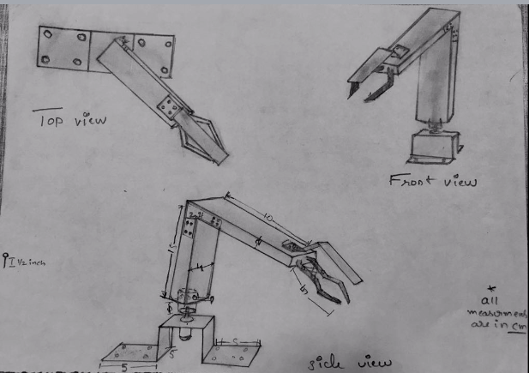

–––

**4.2. Electrical/Electronic Circuit Diagram**

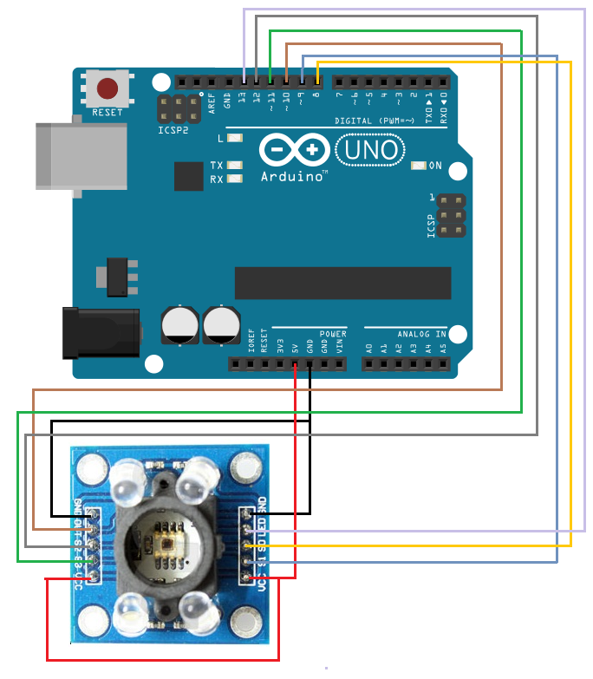

**4.3. Bill of materials**

Table 3: Bill of Materials

|  |  |  |  |  |
| --- | --- | --- | --- | --- |
| Sl.No | Part Name | Material with which the part is made up of | Description about part | Quantity required |
| 1 | L clamps | Metal | Standard size | 4 |
| 2 | Dc motors | standard | Standard | 1 |
| 3 | Gripper | High density foam | Size (10*3) | 1 |
| 4 | Screws | Stainless steel | ½ inch | 10 |
| 5 | Wires | standard | Single stranded | 25 |
| 6 | Battery | Dry cell | 9V, 800mah | 1 |
| 7 | Power driver` | standard | L298N | 1 |
| 8 | Micro controller | Standard | Arduino UNO | 1 |
| 9 | RGB sensor | GY-31 | Forward voltage 2.0, 3.0, 3.2 | 1 |
| 10 | SMPS/Adapter | standard | 12V,1AH | 1 |
| 11 | Switch | -- | --- | 0 |
| 12 | Housingof micro controller | Acrylic sheet | Standard | 1 |
| 13 | Adhesive | standard | Standard | * |

**4.4 Flow Chart for the Program:**

**AUTOMATED BOTTLE SORTING**

Gripper on

Move towards the bottle and hold the bottle

RGB Sensor on

Detects the colour of the cap

Green

Blue

Red

Base motor on

Base motor on

Base motor on

Move anticlockwise for 4 seconds and clockwise for the same delay

Move clockwise for 7 seconds and return for the same delay

Move clockwise for 4 seconds and anticlockwise for the same delay

**4.5. Arduino Program**

**#define s0 4**

**#define s1 5**

**#define s2 6**

**#define s3 7**

**#define sensorOut 3**

**int en1 = 8, in1 = 9, in2 = 10, i = 0, red, blue, green;**

**int en2 = 2, in3 = 11, in4 = 12;**

**int frequency = 0;**

**void setup() {**

**red = 3;**

**blue = 3;**

**green = 3;**

**pinMode(en1, OUTPUT);**

**pinMode(in1, OUTPUT);**

**pinMode(in2, OUTPUT);**

**Serial.begin(9600);**

**//digitalWrite(en1,LOW);**

**while (true) {**

**digitalWrite(en1, HIGH);**

**digitalWrite(in1, HIGH);**

**digitalWrite(in2, LOW);**

**delay(1200);**

**stopTheBottleClutching();**

**break;**

**}**

**}**

**voidstopTheBottleClutching() {**

**digitalWrite(en1, LOW);**

**delay(200);**

**startReadingBottleCapColor();**

**}**

**voidstartReadingBottleCapColor() {**

**Serial.print("Identifying color \t");**

**digitalWrite(s2, LOW);**

**digitalWrite(s3, LOW);**

**red = pulseIn(sensorOut, LOW);**

**Serial.print("RED=");**

**Serial.print(red);**

**Serial.print("\t");**

**delay(250);**

**digitalWrite(s2, HIGH);**

**digitalWrite(s3, HIGH);**

**green = pulseIn(sensorOut, LOW);**

**Serial.print("GREEN=");**

**Serial.print(green);**

**Serial.print("\t");**

**delay(250);**

**digitalWrite(s2, LOW);**

**digitalWrite(s3, HIGH);**

**blue = pulseIn(sensorOut, LOW);**

**Serial.print("BLUE=");**

**Serial.print(blue);**

**Serial.print("\t");**

**Serial.print("\n");**

**delay(250);**

**//0:RED, 1:BLUE, 2:GREEN 3:SOME PROBLEM WITH COLOR IDENTIFICATION.**

**int color = (red < green && red < blue) ? 0 : (blue < red && blue < green) ? 1 : (green > red && green > blue) ? 2 : 3;**

**sortBottle(color);**

**}**

**voidsortBottle(int color) {**

**if (color == 0) {**

**while (true) {**

**digitalWrite(en2, HIGH);**

**digitalWrite(in3, LOW);**

**digitalWrite(in4, HIGH);**

**delay(4000);**

**stopBottlePlacement();**

**dropBottle(color);**

**break;**

**}**

**}**

**if (color == 1) {**

**while (true) {**

**digitalWrite(en2, HIGH);**

**digitalWrite(in3, HIGH);**

**digitalWrite(in4, LOW);**

**delay(4000);**

**stopBottlePlacement();**

**dropBottle(color);**

**break;**

**}**

**}**

**if (color == 2) {**

**while (true) {**

**digitalWrite(en2, HIGH);**

**digitalWrite(in3, HIGH);**

**digitalWrite(in4, LOW);**

**delay(8000);**

**stopBottlePlacement();**

**dropBottle(color);**

**break;**

**}**

**}**

**}**

**voidstopBottlePlacement() {**

**digitalWrite(en2, LOW);**

**delay(200);**

**}**

**voiddropBottle(int color) {**

**while (true) {**

**digitalWrite(en1, HIGH);**

**digitalWrite(in1, LOW);**

**digitalWrite(in2, HIGH);**

**delay(1200);**

**stopOpeningTheClutches();**

**break;**

**}**

**getClutchToOriginalPosition(color);**

**}**

**voidstopOpeningTheClutches() {**

**digitalWrite(en1, LOW);**

**delay(2000);**

**}**

**voidgetClutchToOriginalPosition(int color) {**

**switch (color) {**

**case 0:**

**while (true) {**

**digitalWrite(en2, HIGH);**

**digitalWrite(in3, HIGH);**

**digitalWrite(in4, LOW);**

**delay(4000);**

**digitalWrite(en2, LOW);**

**break;**

**}**

**break;**

**case 1:**

**while (true) {**

**digitalWrite(en2, HIGH);**

**digitalWrite(in3, LOW);**

**digitalWrite(in4, HIGH);**

**delay(4000);**

**digitalWrite(en2, LOW);**

**break;**

**}**

**break;**

**case 2:**

**while (true) {**

**digitalWrite(en2, HIGH);**

**digitalWrite(in3, LOW);**

**digitalWrite(in4, HIGH);**

**delay(8000);**

**digitalWrite(en2, LOW);**

**break;**

**}**

**break;**

**}**

**delay(2000);**

**setup();**

**}**

**void loop() {}**

**4.6. Project Backlog Sheet**

**4.6.1. Identified Functions:**

|  |  |
| --- | --- |
| Sl. No | Functions |
| 1) | Sense the presence of bottle. |
| 2) | Locate the bottle |
| 3) | Approach the bottle |
| 4) | Placing the sensor on top of the bottle. |
| 5) | Sensing the colour of the cap/shape/size of the bottle |
| 6) | Placing the bottle in assigned zones. |

**4.6.2. Sub systems Identified based on the functions**

|  |  |
| --- | --- |
| Sl. No | Sub Systems |
| 1 | Approaching the bottle |
| 2 | Sensing the presence of the bottle |
| 3 | Sorting based on colour |

**5. Implementation**

**5.1. Photographs**

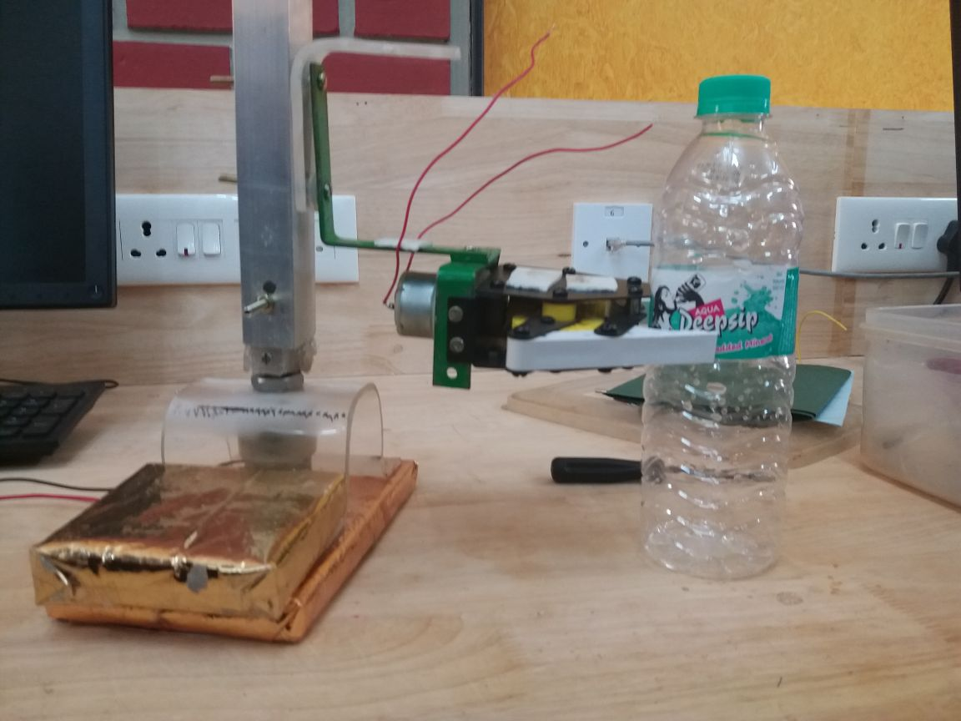

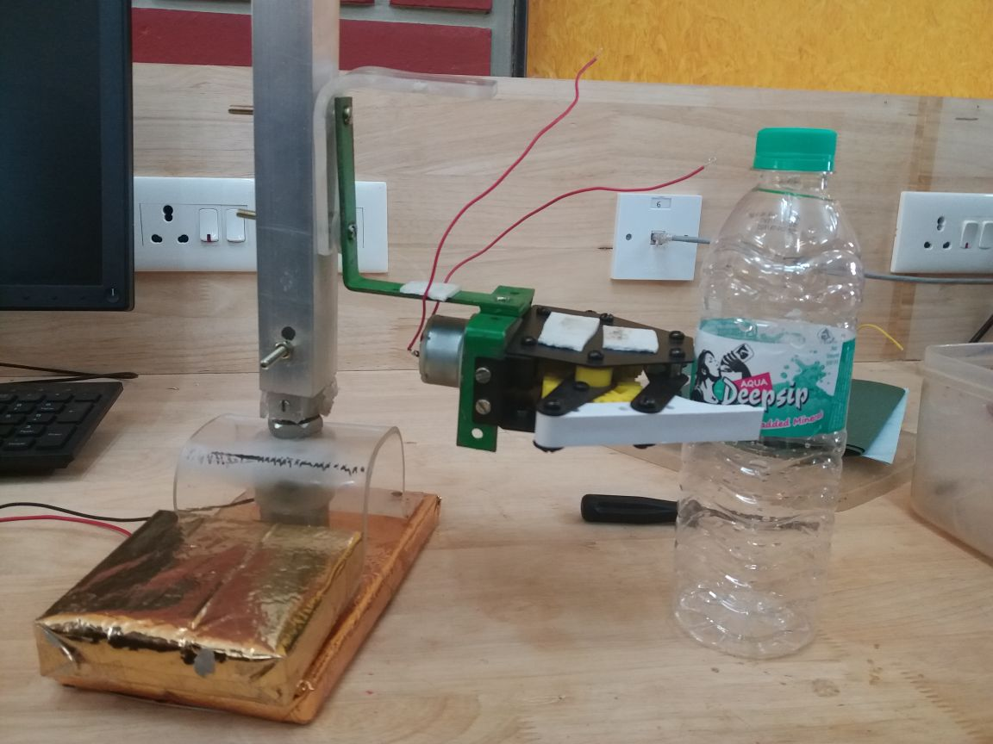

**5.2.Project Implementation Progress**

**This page will be replaced by hard copy of your Implementation Progress sheet duly signed by your guide on each sprint.**

|  |  |  |  |  |
| --- | --- | --- | --- | --- |
| Sprints | | **Planning phase** | **Building phase** | **Testing phase** |
| **Sprint 1** | **Planned dates** | **5/11/17** | **8/11/17** | **10/11/17** |
| **Completion dates** | **5/11/17** | **10/11/17** | **11/11/17** |
| **Sprint 2** | **Planned dates** | **7/11/17** | **8/11/17** | **10/11/17** |
| **Completion dates** | **7/11/17** | **10/11/17** | **11/11/17** |
| **Sprint 3** | **Planned dates** | **15/11/17** | **17/11/17** | **23/11/17** |
| **Completion dates** | **15/11/17** | **19/11/17** | **25/11/17** |

**5.3. Statement of Expenditure**

Table 4: Statement of Expenditure

|  |  |  |  |
| --- | --- | --- | --- |
| Sl. No | Item with description | Quantity | Price in Rs. |
| 1 | Gripper | 1 | 750 |
| 2 | ArduinoUNO | 1 | 500 |
| 3 | DC motor | 1 | 250 |
| 4 | Motor driver | 1 | 250 |
| 5 | Square section | 1 | 140 |
| 6 | RGB sensor | 1 | 329 |
| 7 | SMPS/Adapter | 1 | 200 |
| Total | | | 2419 |

**6. Limitations of Present work and Future Scope**

* The primary disadvantage of the selection sort is its poor efficiency when dealing with a huge list of items.
* The selection sort requires n-squared number of steps for sorting n elements.
* Requires extra space »N
* The main disadvantage is the fact that it does not deal well with a list containing a huge number of items.
* This is mostly suitable for academic teaching but not for real-life applications.
* With n-squared steps required for every n element to be sorted, this does not deal well with a huge list.
* This  is less efficient
* The bottle must be placed from top into the gripper module
* The RGB(gy-31) is not so accurate

**Future scope**

The key to the efficient use of robotics is the pre-sorting distribution of the product. Large bulky items that can be mechanically sorted through a standard Robotic arm eliminates the amount of waste that the robot must sort through. In addition, waste that is evenly distributed on the conveyor as it enters the robotic area makes it easy for the sensors to select items for

The robatic arm to pick up and sort Bibliography:-

1. web pages:

1) <https://en.wikipedia.org/wiki/sorting>

2) <https://stayathomeeducator.com/six-ways-to-sort-bottle-caps/>

3)<https://youtu.be/lslSXQAkVSw>

4)<https://youtu.be/qmADj6uyrW0>

5) <https://howtomechatronics.com/projects/arduino-color-sorter-project/>

6) <https://youtu.be/STcLwXRj4Gl>

7) <https://youtu.be/31v1dT7V7zY>

8)<https://m.alibaba.com/showroom/platic-sorting-machine.html>